

**Gatherbot**

**Final Report**

**Team Members**

Raman Kooner

Jesus Lucena

James Chomchan

Allura Jackson

CECS 490A - Spring 2019

May 17th, 2019

This report documents the progression for the Gatherbot design team, including a project overview, customer needs, detailed project specification and functionality, and several preliminary diagrams.

**Table of Contents**

**Team Members** **3**

**Project Overview** **4**

**Project Implementation** **6**

**Customer Needs** **9**

**Project Specifications** **10**

**Subcomponent Descriptions** **11**

**Overall System Functional Block Diagram** **22**

**Complete Schematic** **25**

**Power Management** **28**

**Project Management** **30**

**Circuit Simulation and Verification** **33**

**Software Verification** **34**

**Software Flow Chart** **36**

**Similar Products** **37**

**Societal and Environmental Impact** **38**

**References** **39**

# **Team Members**









# **Project Overview**

The Gatherbot is to be a fully autonomous robot that will identify orange ping pong balls within a traversable area, pick them up, and place them in a designated location. As a finished product, the Gatherbot will demonstrate the capabilities of autonomous movement, object recognition, and item collection, albeit for a small-scale application. However, the aspects of the Gatherbot can be extended further. Provided that computers and machines are progressing toward the age of autonomy, the Gatherbot has the potential to serve as an alternative for a various scenarios. Such scenarios include applications in agriculture, in which this technology can be used to harvest produce, or perhaps even the planting of seeds for a new crop. Businesses can consider this type of robot to be a solution to menial labor in logistics, such as warehouse robots that move materials and update their locations to a database. Development of the Gatherbot thus explores this potential, scaled-down to picking up and placing ping pong balls.

*Figure 1. Gatherbot Design Model*

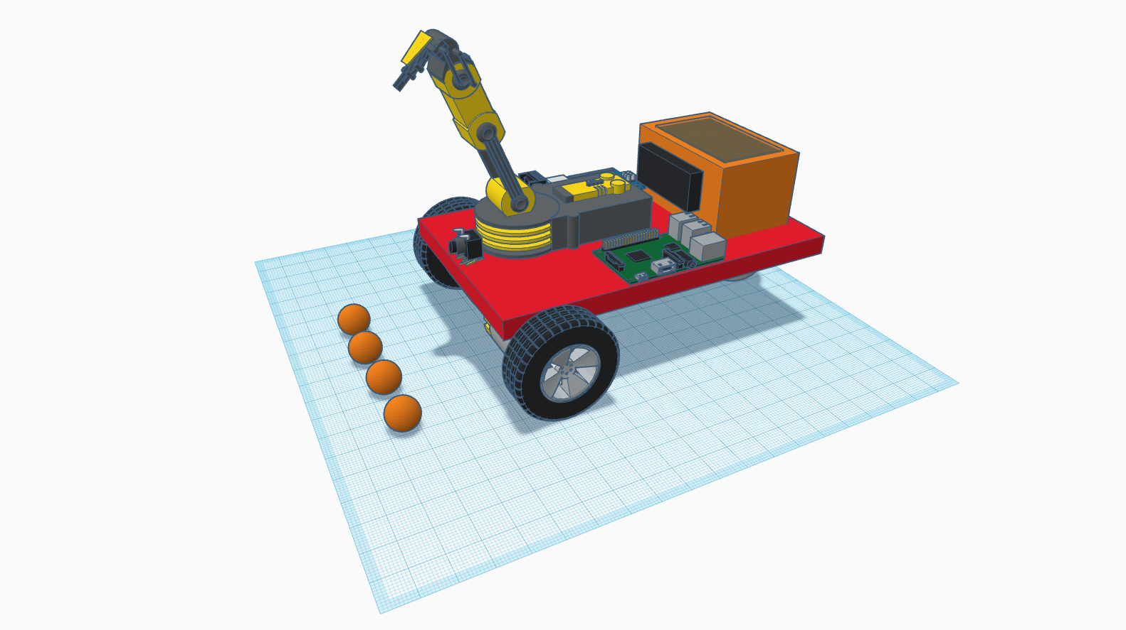

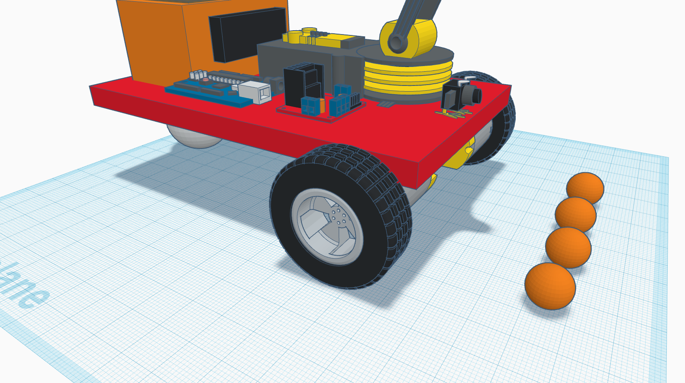

*Figure 2. Original Gatherbot Design Sketch*

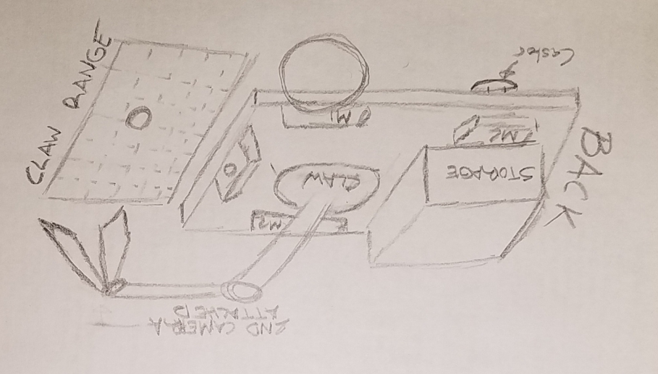

# **Project Implementation**

Overview

Designing the Gatherbot involves understanding both the hardware and software aspects behind autonomous robot technology. The Gatherbot needs to be able to obtain visual data not only from the front but also around the entire robot in order to be able to find the ping pong balls in its environment and avoid obstacles. The electronics for the robot, which are detailed in the subcomponents section, are divided into two overall modules. The first module of the design is considered as the “brain” of the system, which consists of all the hardware and software that will obtain the necessary information from the space around Gatherbot and process the information to make decisions. The second module of the design is classified as the “functional body” of the system, which will execute the functions that the Gatherbot will be able to accomplish: find, pick up, and place.

The Brain

The “brain” of the Gatherbot will be implemented using the Raspberry Pi 3 Model B, a small single-board computer capable of processing image and video data. In order to obtain visual information of the objects and obstacles in the area around the Gatherbot, a camera module manufactured specifically for the Raspberry Pi is used to create the machine vision aspect of the design. The video feed from the camera is acquired by the Raspberry Pi computer, which will then process the video frame-by-frame and make decisions based on what the robot can see. To accomplish the image processing requirements for the system, the OpenCV Python library is used. OpenCV is a computer vision library originally developed by Intel that contains image processing functions that will assist in identifying objects in an image. The method that we are using to identify ping pong balls in a video feed is called color and contour object identification.

Color and contour object identification is a method of finding objects in an image by looking for specific colors and shapes. The Gatherbot looks specifically for orange ping pong balls. Having established this, the software must then be able to search for the color orange in an image frame, and check to see if the shape of the orange object is that of a circle. Using OpenCV, a frame from the incoming video feed of the front-facing camera is captured. The image is first blurred using a Gaussian filter function from the OpenCV library. Blurring the image reduces the detail of the image and smooths the transitions between the color of one pixel to the color of another pixel, thus allowing the computer vision to better distinguish changes in color. This frame is then converted from a BGR color space to an HSV color space. The HSV color space is used frequently in computer vision applications instead of the BGR color space due to it being able to separate color from the brightness of an image. This allows the digital image processing algorithm to distinguish the colors of objects in an image despite changes to lighting and shadows. After converting to the HSV color space, the image goes under further processing by using functions to search for portions of the image that fall within the HSV bounds of the color orange.

Contours for the portions that are determined to be orange are created. Using these contours, we can check their shape. If the shape is a circle, the system concludes that the object in question is an orange ball. The center of the contour is labelled as the position of the ball in the image frame. With this information, the robot then knows the orientation of where the ball is in respect to the front of the robot. Distance algorithms such as triangle similarity will be used to determine the distance from the camera to the ball. Depending on whether or not the robot is in range to pick up the object, the Raspberry Pi will send commands to the TM4C123G microcontroller, which will then control other hardware components.

The Body

The “body” of the Gatherbot consists of the components that allow the robot to move and interact with the environment. The TM4C123G microcontroller will serve as an intermediary processing unit between the Raspberry Pi “brain” and all electronic components found on the robot. Depending on the information received from the Raspberry Pi via a UART interface, the TM4C123G will control the motors of the robot and move into range of picking up the ping pong balls. The camera for the robot will be mounted in the direct center of the frontside of the robot. Upon starting up, the robot will perform a looping algorithm that searches for the first ping pong ball. This algorithm begins with checking if a ping pong ball is in the starting field of view. If there is, the robot shall move into range of the ball. If there isn’t a ping pong ball in its field of view, the robot will begin to rotate. During this rotation, the robot continuously checks for any ping pong balls. If a situation arises where the robot does not detect any ping pong balls during this rotation, the robot will move forward a predetermined distance and repeat the cycle. Once the robot has detected ball, the robot needs to ensure that the ping pong ball is in the dead center of its field of view. Centering the ball in front of the robot occurs once the ball has been detected. Movement towards the ball tries to keep the ball in the center of its view, and the robot will continue to move towards the ball until it is within reachable distance for the mounted arm to pick it up. The method of centering the ball is by checking if the distance from the left edge of the screen to the left edge of the ball is equivalent to the distance from the right edge of the screen to the right edge of the ball. Ensuring that the ball is centered also includes checking if the coordinates of the ball’s center line up correctly with the centroid of the screen.

The movement of the robotic arm is planned to be a static motion, meaning that the motion will be executed every time the robot is within range of the ball. This entails that the movement of the robot with respect to the ball must be consistent and accurate. When the robotic arms attempts to pick up the ball, we are expecting to have the ball at a certain distance away from the robot every time. Once the robotic arm has performed the action of picking up the ball, it will attempt to place it in the storage compartment located in the rear of the robot. This motion will also be a static procedure for the arm. A sensor located in the compartment will notify when a new object has been stored, and then increment a counter keeping track of how many objects we have picked up. The maximum capacity of this storage is 15 ping pong balls. Once this number has been reached, Gatherbot will enter a mode in which it will search for a storage location for the ping pong balls.

Similarly to how the robot searches for ping pong balls, the robot will search for a drop-off location in a similar manner. A designated area with short, colored walls will be detected by the front camera of the robot. Once the robot is next to the drop-off area, it will perform a static routine of rotating 180 degrees, back up slightly into the drop-off area, and releasing the hatch holding the ping pong balls. After this motion, the robot will begin to look for more ping pong balls. This cycle shall repeat until no other ping pong balls are within the working space of the robot, which is defined as at most a 20 square feet area. The only user interface available to be used by the robot is the power switch.

# **Customer Needs**

This section addresses the needs requested by the end-user.

* Durability: The robot must be able to withstand the wear and tear of moving parts while being able to maintain the quality of its functionalities.
  + The structure of the robot has to be sturdy enough to be able to pick up and hold a number of objects without making the robot function inefficiently.
* Performance: The robot must be able to identify objects and pick them up at a decent rate.
* Reliability: The robot must be able to pick up objects reliably and with a low chance of failure.
  + The manner in which the robot picks up objects should not in any shape or form do damage to the object involved.
  + In the possible case of failure, the robot must be able to attempt at picking up the object until it is done successfully.
* Versatility: The robot must be able to adapt to changes in the area surrounding it without having any impedance on reaching its goal.
* Safety: The handling of components to the robot must be harmless to the end-user.
* Battery Life: The robot needs to be able to use AA batteries efficiently without draining them too quickly.
* Lifespan: All aspects of the robot should last in full-working condition over the course of one to two years with no maintenance.
* The customer should be able to decide when to have the robot actively search for and gather items or when to sit idle when powered on.
* The robot should be able to hold a minimum of 10 standard-sized ping pong balls
* When the robot cannot store any more ping pong balls, the robot should autonomously find a designated area for dumping all the ping pong balls before actively searching for ping pong balls again.
* The robot should not pick up the ping pong balls from the designated storage area.
* The end-user wants the robot to have the following interface features:
  + Power Switch
  + Mode Toggle Button
* The robot needs to be able to be carried freely by human hands, not requiring an extra mode of transporting the final design.
* The robot needs to indicate to the end-user the current mode.

# 

# **Project Specifications**

This section documents all specifications for designing the Gatherbot, addressing capabilities and constraints for the design.

**Physical Design:**

* Robot car design with storage “trunk”.
  + Enclosed metal chassis for main body.
  + 5 in. x 5 in. x 4 in. storage “trunk” for holding objects.
  + Maximum Capacity: 15 ping pong balls
* Wheel and motor form of locomotion.
  + Full range of motion for an X-Y plane [left, right, forward, backward].
  + Two motors and a single castor wheel.
* Robot arm used as the method of picking up objects.
  + Aluminum frame
  + Two prong clasp with rubber grips
* Camera used as method of scanning for objects in space.

**System Specifications:**

* Autonomous Item Gathering
  + No control schemes besides mode button.
  + Active scanning for orange ping pong balls picked up on camera.
  + Robot arm picks up desired objects directly in front of the robot.
  + System acknowledges maximum carrying capacity.
  + Able to locate a designated area to drop-off the carried load.
* Object Recognition
  + Identify and target orange ping pong balls, distinguishing them from other similar objects.
* Collision Avoidance
  + Uses data acquired from camera and sensors to determine potential impact with obstacles and avoid them.
  + Guide: Robot will avoid obstacles coming within a 3.5 inch range around the robot.
* Robot Localization
  + Actively functions within a 15 ft. x 15 ft. area around the robot upon start.
* LED/LCD mode display to user.

**Hardware Characteristics:**

* Switch-Mode Power Supply to provide DC voltage to components

# **Subcomponent Descriptions**

**TM4C123G LaunchPad**

The TM4C123G LaunchPad is a evaluation platform that uses the 32-bit ARM Cortex-M4 based microcontroller CPU. It has a 16MHz clock that can go up to 80MHz and has 256kb flash, 32kb SRAM and 2kb EEPROM. The TM4C also includes 8 UART, 6 I2C and 4 SPI communications. The board requires 4.75V to 5.25V from the debugger USB cable or the USB device cable. It features two PWM modules capable of generating 16 PWM outputs. We will use the TM4C123G LaunchPad in our project to control the movement of our robot, measure the distance from the robot to the ping pong ball and control the movement of our robotic arm. We will be using the PWM modules to control our motors and a timer module for our measurement of distance.

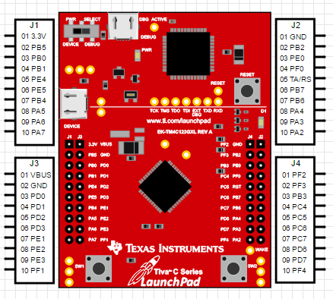

*Figure 3. TM4C123G Launchpad Pinout*

*Figure 4. TM4C123G Launchpad Pin Locations and Names*

*Figure 5. TM4C123G Launchpad Reset and Oscillator Schematic*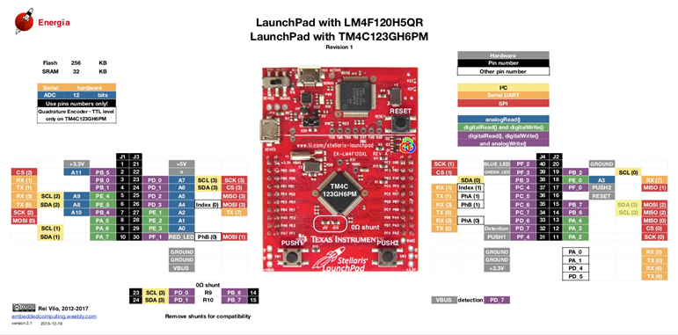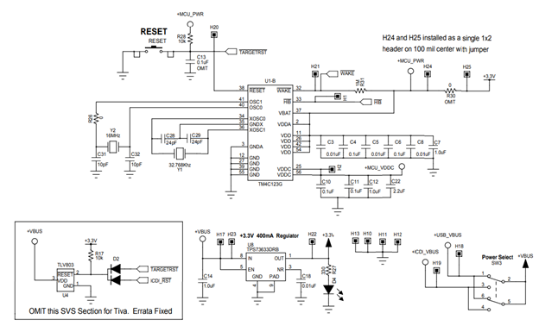

**Raspberry Pi 3 Model B**

The Raspberry Pi 3 Model B is an open-source minicomputer capable of doing multiple tasks. It has a Cortex-A53 64-bit system on chip and runs at 1.4 GHz. The board contains a 1 GB SDRAM and a Bluetooth low energy wireless communication. It has an extended 40-pin GPIO, HDMI, 4 USB 2.0 ports, a camera port, and micro SD port. The main area of usage of a Raspberry Pi include controlling a complicated robot, doing intense calculations and performing multiple tasks. We will use the Raspberry Pi in our robot to do object recognition and process data from a live video using the OpenCV library. We will use two cameras on our Raspberry Pi: Pi camera and a USB webcam. The two cameras will be responsible for tracking an orange ping pong ball and sending back the X and Y coordinates of the ping pong ball. Our Raspberry Pi will communicate the X and Y coordinates of the ping pong ball to the TM4C123G microcontroller using UART communication.

*Figure 6. Raspberry Pi 3 Model B GPIO*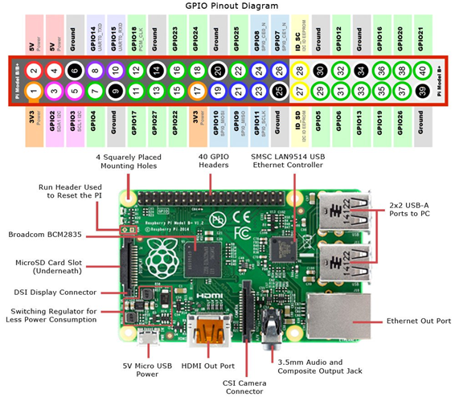

**Raspberry Pi Camera Module v2**

The Raspberry Pi camera module v2 has a Sony IMX219 8-megapixel sensor and is used to take high-definition video and pictures for the Raspberry Pi. The camera supports 1080p30, 720p60 and VGA90 video modes. It has an attached 15cm ribbon cable that gets connected to the CSI port on the Raspberry Pi. The Raspberry Pi includes multiple third party APIs to access the camera. The most popular API for the Raspberry Pi camera is the Picamera Python library. In our project, the Picamera is used to for object detection to allow our robot to detect orange ping pong balls.

*Figure 7. Raspberry Pi Camera Module v2*

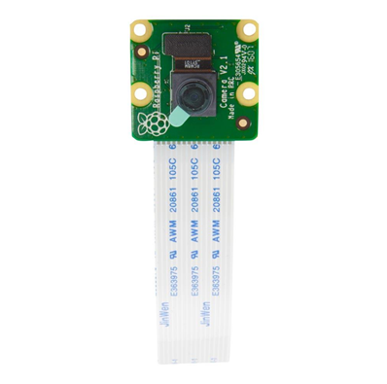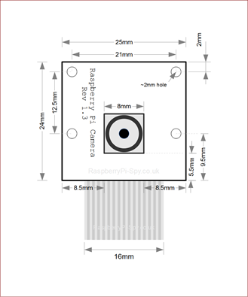

**HC-SR04 Ultrasonic Sensor**

Ultrasonic sensors were designed to measure distances using ultrasonic waves. It works by emitting an ultrasonic wave and receiving the wave that is reflected back from the target object. The trig pin is used to transmit the high frequency sound and the echo pin is used to receive the signal. It uses the time between the emission and reception to measure the distance to the target object using the formula:

L = ½ x T x C

In this formula, L is the distance, T is the time between emission and transmission and C is the sonic speed (speed of sound). The distance is multiplied by ½ because we have to take in to account the time for go-and-return distance. In our project, we will use the ultrasonic sensor to measure the distance from the robot to the ping pong ball. We will take this measurement and compare it to the measurement we find from our camera on our robot.

*Figure 8. Ultrasonic Sensor Function*

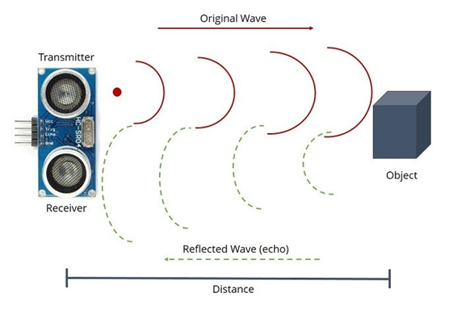

Some features of the HC-SR04 ultrasonic sensor include:

* 5V DC power supply
* 15 mA working current
* 2 cm - 400 cm ranging distance
* 0.3 cm resolution
* 10 uS trigger pulse

*Figure 9. Ultrasonic Transmitter & Receiver Circuit*

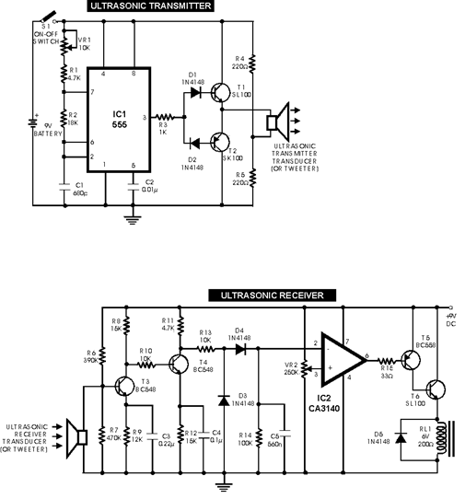

**L298N H-Bridge Motor Driver**

An h-bridge is an electronic circuit that switches the polarity of voltage to a load in order to enable bidirectional functionality. Our robot will use the L298N h-bridge motor driver to control our DC motors. An h-bridge is made out of four transistors and a load in the middle. The transistors act as switches and control the direction of the motors depending on which switches are open and which switches are closed.

The transistors and diodes showed in this schematic are field-effect transistors and catch diodes. The diodes are responsible for ensuring the flow of current in only one direction. Without the diodes, there is a risk of voltage rises that can damage the transistors. When Q1 and Q4 are turned on, the motor will turn in the forward direction and when Q2 and Q3 are turned on, the motor will turn in the reverse direction. One problem that can occur is “shoot through” which is caused when Q1 and Q2 are turned on at the same time which creates a low-resistance path, causing a short in the power supply.

*Figure 10. H-Bridge Schematic*

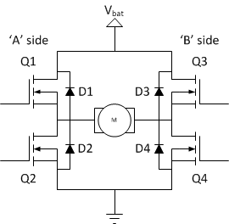

H-Bridges allow the use of PWM in order to drive the motors. PWM (pulse width modulation) is a periodic signal with a constant frequency that has an “on-time” and an “off-time.” We can control the speed of the motors by adjusting the duty cycle of the PWM. Some advantages to using PWM include greater efficiency, less heat dissipation and higher power output.

*Figure 11. L298N H-Bridge Detailed Schematic*

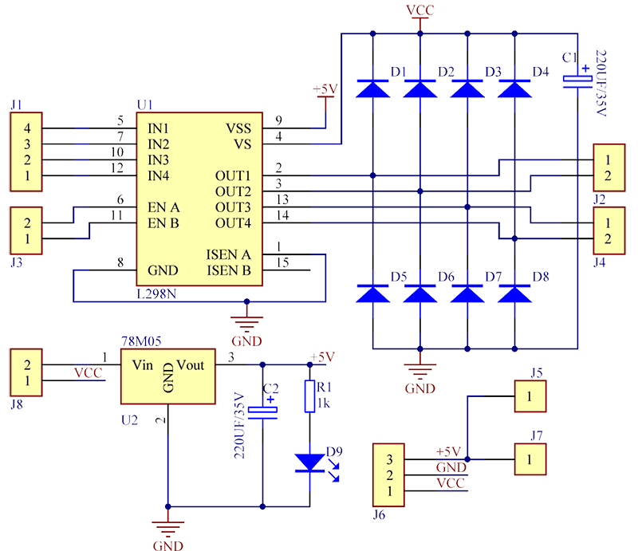

**DC Motors**

DC motors convert electrical energy into mechanical energy and are made of a stator, an armature, a rotor and a commutator with brushes. The armature is placed on the rotor and the commutator switches the current flow from one coil to the other coil. They are equipped with magnets to produce a magnetic field to form the stator. Current passes through the wires between the magnets and creates a field that interacts with the field from the magnets to apply torque. The problem with the commutator is that the brushes (electric contacts on the commutator) connect the power source to the armature and at certain times during the rotation of the DC motor, the commutator must reverse the current which can lead to decreased motor life due to friction. Brushless DC motors avoid this problem by making the rotor’s permanent magnet field make the rotor field and not having the commutator carry the current to the rotor. We will use DC motors in our project to control our robot wheels and the speed of the DC motors will be controlled with pulse width modulation. The higher the pulse, the faster the motors will go. The DC motors will be connected to the TM4C123G microcontroller and powered with 6 volts each.

*Figure 12. DC Motor Diagram*

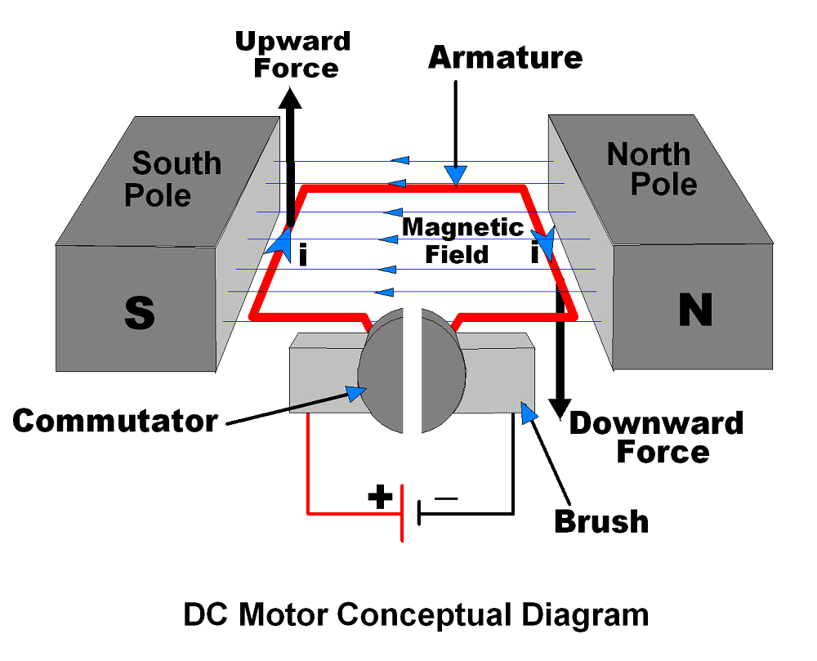

**Servo Motors**

Servo motors are rotary actuators that have a precise control for velocity, acceleration and angular or linear position. It controls its motion and final position with a closed-loop servomechanism and position feedback which is provided by an encoder. Servo motors are created by a small DC motor, potentiometer and a control circuit. The motor controls the wheel on the servo motor with attached gears and as the motor rotates, the potentiometer resistance changes. The potentiometer allows the control circuit to precisely regulate the amount of movement that has taken place and the direction of the movement. Servo motors are controlled by pulse width modulation and the length of the pulse will determine the amount of degrees that the motor will turn. There are two types of servo motors: AC servos and DC servos. AC servo motors can handle higher current and are used in industrial machinery while DC servo motors are suited for smaller applications such as robots and hobby projects. We will implement servo motors into our project to assist with the movement of our robotic arm. Our robotic arm will have a servo motor connected to the base of the arm, the claw and in the center of the arm as a joint. The servo motor at the base of the arm will be used to move the arm 180 degrees in order to place ping pong balls in our storage area and the servo motor in the center of the arm will be used as a joint so that our robot can pick ping pong balls from the ground. The servo motor connected to the claw will be used to open and close the claw to create a firm grip on the ping pong ball.

*Figure 13. Servo Motor Schematic*

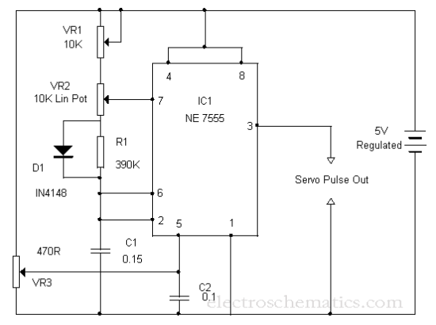

*Figure 14. Servo Motor Driver Schematic*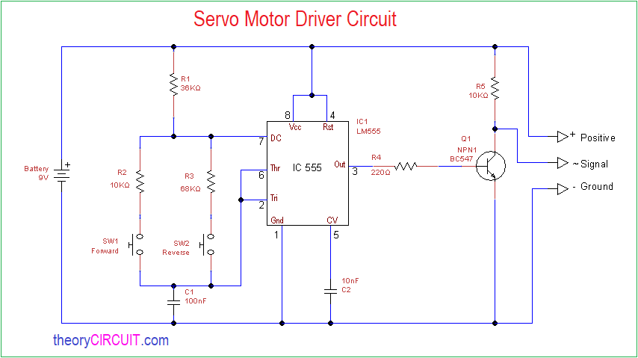

# 

# **Overall System Functional Block Diagram**

Figure 15. Gatherbot Functional Block Diagram

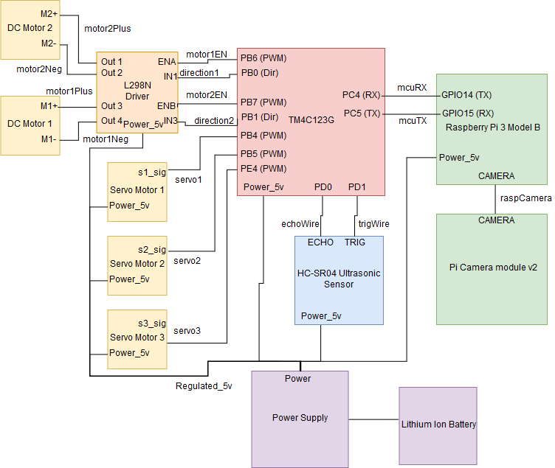

*Figure 16. Table for Gatherbot Hardware Connections*

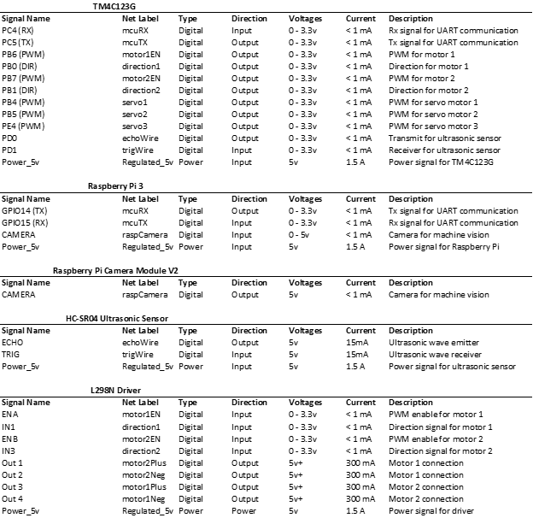

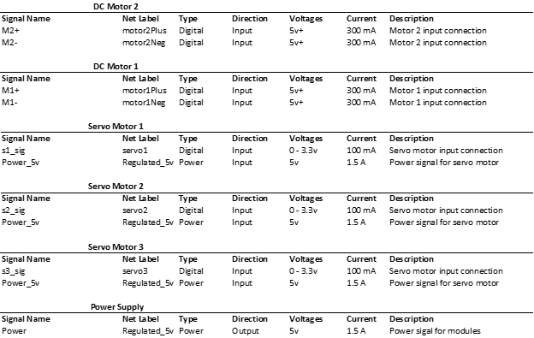

# **Complete Schematic**

*Figure 17. Gatherbot Preliminary Schematic*

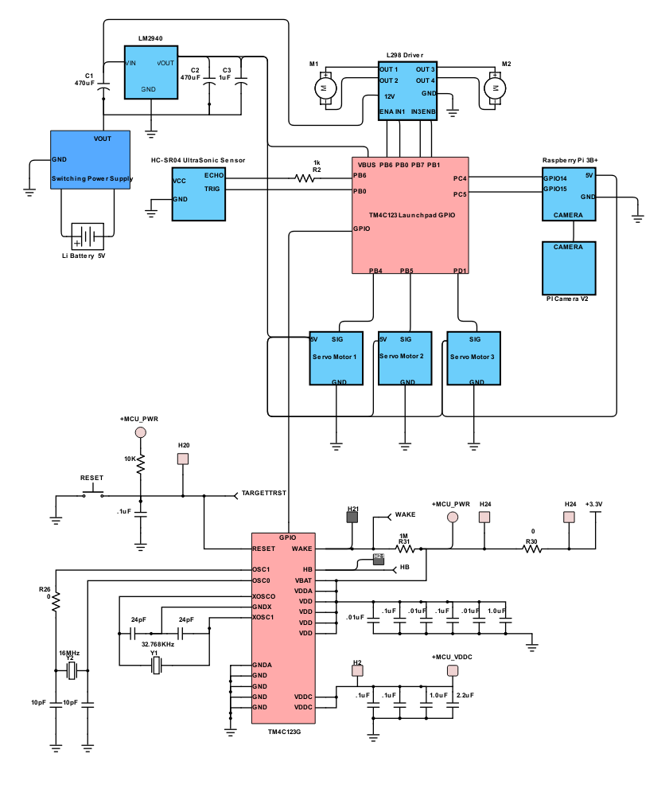

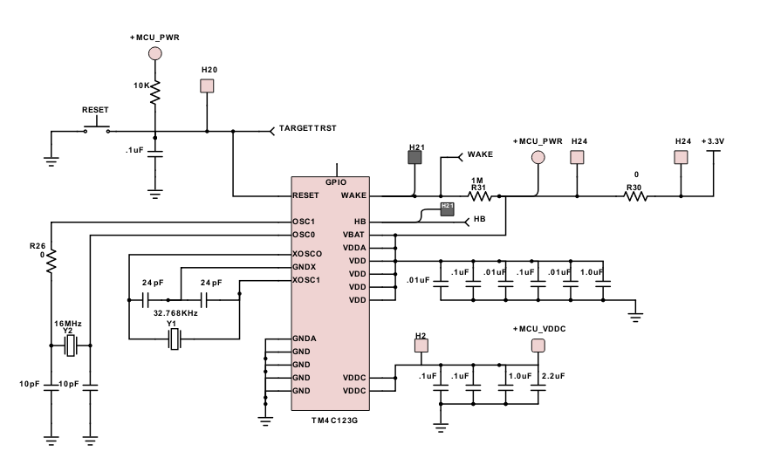

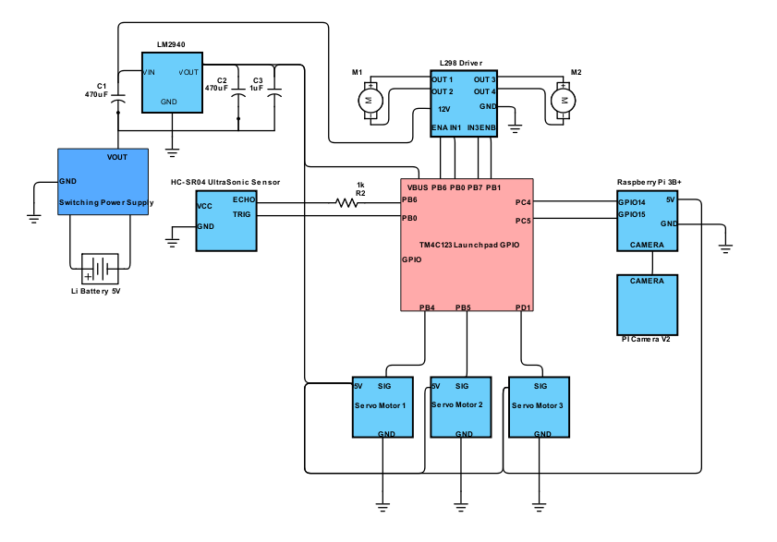

Bill of Materials:

|  |  |  |  |  |  |
| --- | --- | --- | --- | --- | --- |
| BOM ID# | Name | Manufacturer | Unit Price | Quantity | Total Cost |
| 1 | Raspberry Pi Camera V2 | Raspberry Pi Foundation | $13 | 1 | $13 |
| 2 | Raspberry Pi 3 | Raspberry Pi Foundation | $35 | 1 | $35 |
| 3 | DC Motors | ... | ~ $12 | 2 | ~ $24 |
| 4 | Robotic Arm Kit | ... | ~ $40 | 1 | ~ $40 |
| 5 | Robot Frame | ... | ~ $20 | 1 | ~ $20 |
| 6 | Servo Motors | ... | ~$10 | 3 | ~$30 |
| 7 | Castor Wheel | ... | $3 | 1 | $3 |
| 8 | Ultrasonic Sensor | SainSmart | ~ $10 | 1 | ~ $10 |
| 9 | PCB Board | ... | ~ $20 | ... | ... |
| 10 | Power Supply | Texas Instruments | ~ $10 | 1 | ~ $10 |

# **Power Management**

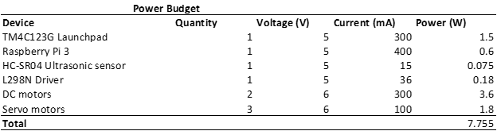

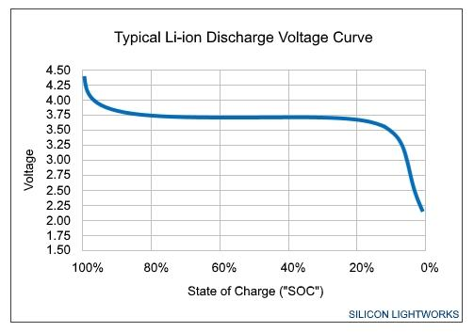

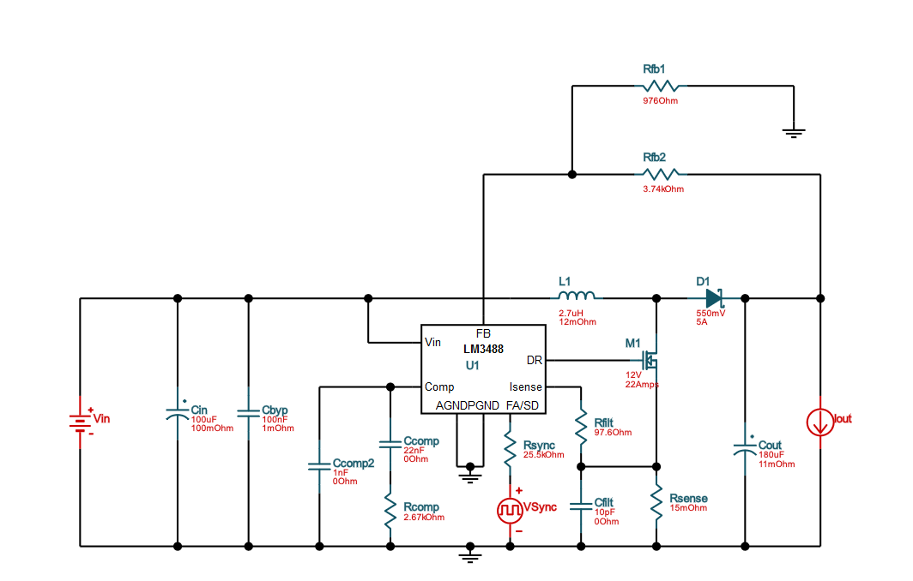

A boost power supply is a circuit that steps up the voltage and steps down the current. This means that we get a higher voltage output than input. Our project will be using a boost switching power supply with a 3.7 volt input and 6 volt output. The input to our power supply will be a 3.7 volt lithium ion rechargeable battery with 2000mAh. The power supply circuit will be capable of outputting at least 1.5A of current with 89.1% efficiency. The lithium ion battery will have a steady voltage of 3.7 volts until it hits a 20% state of charge. Some advantages to using lithium ion batteries include high energy density, low self-discharge and its ability to provide high current.

# **Project Management**

**Work Breakdown Structure**

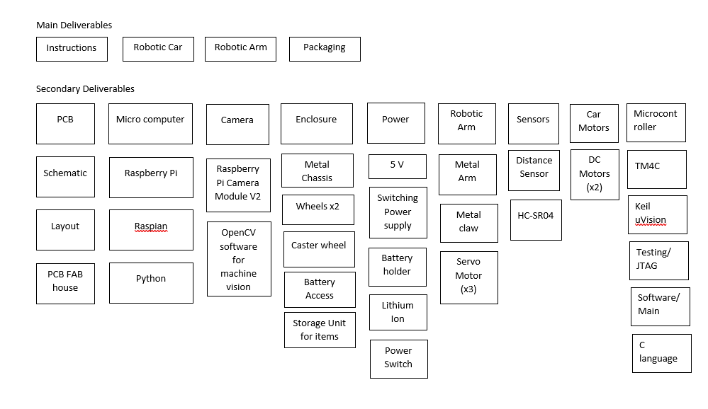

**5 Demos Contract**

1. **Robot Car centered on ping pong ball**
   1. Using the input from the HC-SR04 ultrasonic sensor and the X and Y-coordinates from the Raspberry Pi, the robot is able to correctly position itself in the center of the ping pong ball and continuously positions itself in the center of the robot car as it moves towards the ping pong ball.
2. **Obstacle avoidance and machine localization algorithm** 
   1. The robot will use sensors and cameras to navigate through an obstacle course that we set up. The robot will also implement the algorithm which we create when there are no ping pong balls in front of the robot.
3. **Robot successfully picks up ping pong ball with robotic arm and places it in the storage compartment.**
   1. The robot must be able to approach the ping pong ball and center itself directly in front of it. The mounted arm should automatically begin its pick up routine once the ping pong ball is in range of the robot. Upon successfully grasping the ball, it should be able to store it in the rear compartment.
4. **Robot is able to find the designated drop off spot in a room**
   1. The robot will be able to navigate through a room and find and locate the destination drop off area.
5. **Robot is able to successfully pick up an object and return it to the destination from start to finish.**
   1. The final task will require our robot to pick up multiple ping pong balls and store them in the storage area of our robot. The robot will then return and dump all the ping pong balls in the designated drop off area.

# **Circuit Simulation and Verification**

Through verification of our switching power supply circuit, we will be able to anticipate the output voltage and current that will be used by all the hardware in our design. Using the Webench®️ Power Designer tool created by Texas Instruments, we were able to not only search for possible switching power supplies to use, but also verify the output voltage and current that will be powering all components in our design.

In our design, the DC motors requires the greatest amount of current at approximately 300 mA per motor. Although the Raspberry Pi requires around 400 mA of current, there are two DC motors in our design. According to our power budget, the total amount of power needed for all components is 7 Watts. Thus, we are looking for a power supply that can supply 6 volts of output and satisfy 7 watts of power. The following waveforms simulate a power supply of 6 volts out and 1.5 amps.

# 

# 

# **Software Verification**

In order to consider the demonstration of the computer vision algorithm used for object detection as a success, we needed to be able to receive some form of data in regards to the ball. Detection of an orange ping pong ball was accomplished through research of the color-contour algorithm for detecting an object. After drawing the contour lines for the object being detected, obtaining the center of the contour would be equivalent to finding the location of the ball in a 2D image. This is accomplished by using moments() function of the OpenCV library, which returns a data structure of moment values that can be used to compute the centroid of the contour.

To ensure that this method works, an emulation of the Raspberry Pi camera video feed was created by outputting image frames of the OpenCV software. When an object is detected, the enclosing circle for a single ping pong ball in the video feed is drawn. The centroid of this circle is displayed to the resulting frames as well. By comparing the visual circle to the centroid values shown on the display, we verified that the method used to compute the centroid is correct. The following images show various positions of the ping pong ball in robots line of sight.

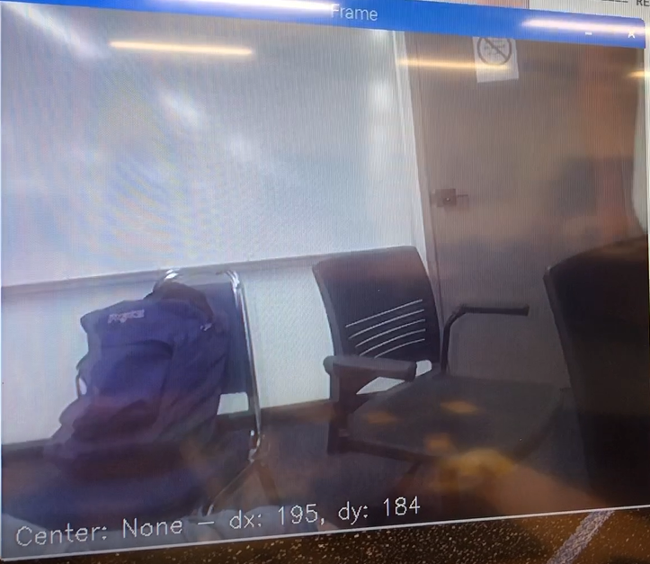

Software Demo - Figure A.

This image verifies the scenario in which the computer does not detect any objects. As stated in the bottom-left corner of the video feed, the information labelled ‘Center’ shows a value of ‘None’. This is expected for when there are not any orange ping pong balls within view of the camera.

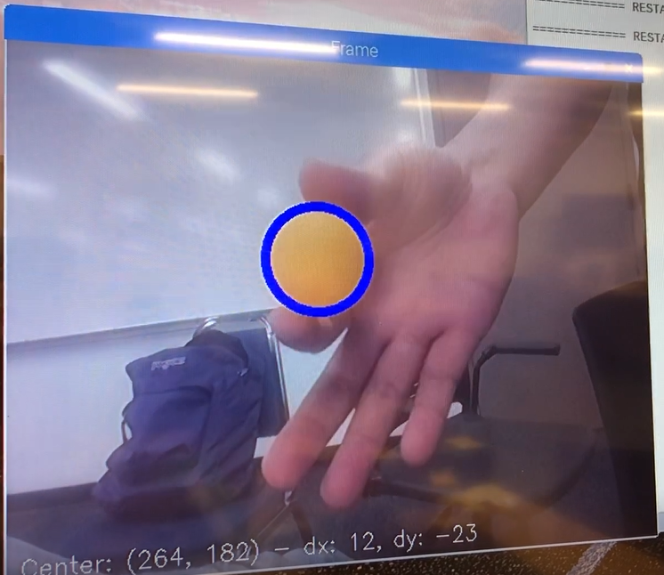

Software Demo - Figure B

This image verifies the scenario in which the computer detects a single ping pong ball in its field of view. By observation, the ball is close to the center of the video feed. The resolution of the video feed is a width of 600 pixels and a height of 480 pixels. The coordinates

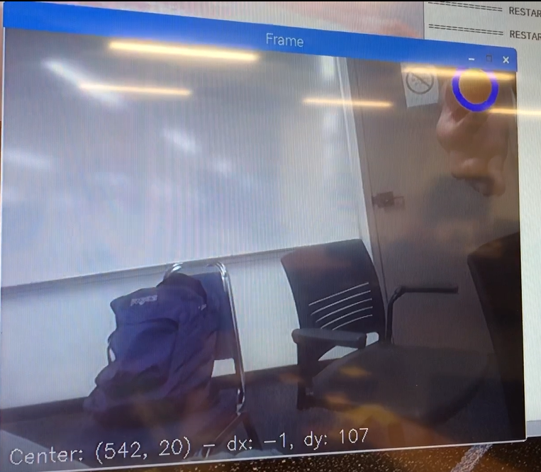

Software Demo - Figure C

This image verifies the scenario in which the computer is still detecting the same ping pong ball, except that the location of the ball has changed. The center coordinates displayed on screen should have changed correctly. The centroid coordinates of “(542, 20)” is expected. The right side of the screen should be a value close to 600. The top edge of the screen should be a value close to 0.

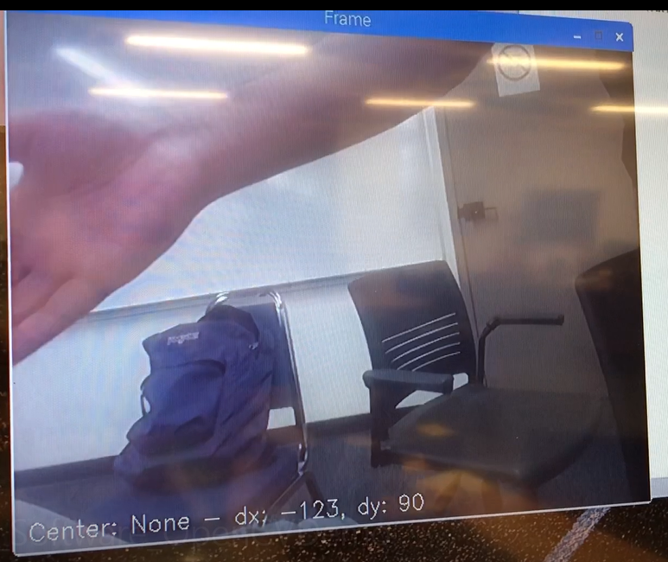

Software Demo - Figure D

In this image, the ping pong ball was previously in view of the camera. Once the ball had moved off the screen, the enclosing circle identifying the object disappeared. Due to the lack of an enclosing circle, the image lacks any desired centroid. The resulting ‘None’ verifies that the object detection system updates correctly upon losing sight of the ping pong ball.

# **Software Flow Chart**

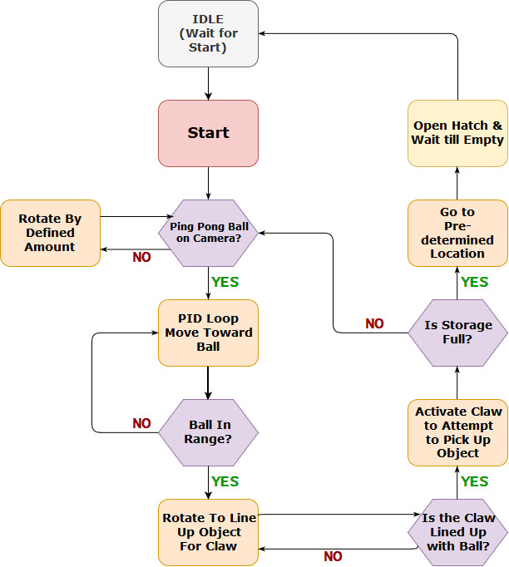

# **Similar Products**

HD2 “Mastiff”:

The HD2 “Mastiff” is a heavy duty robot with a multi-axis arm. It’s features include a tracked designed to climb over obstacles, a 360 degree Pan-Tilt-Zoom camera and a multi-axis arm for versatility. The robot is used for military applications such as opening doors, clearing rooms, remote surveillance, remote manipulation and bomb disposal. It has a run time of up to 8 hours and speed of 0 to 120 ft per minute. The multi-axis arm is a 4-axis arm with 180 degrees shoulder rotation, 270 degrees elbow rotation and a continuous wrist rotation. The robotic comes with a WiFi control system or a 2.4GHz digital control system.

<http://sdrtactical.com/HD2Arm-Mastiff/>

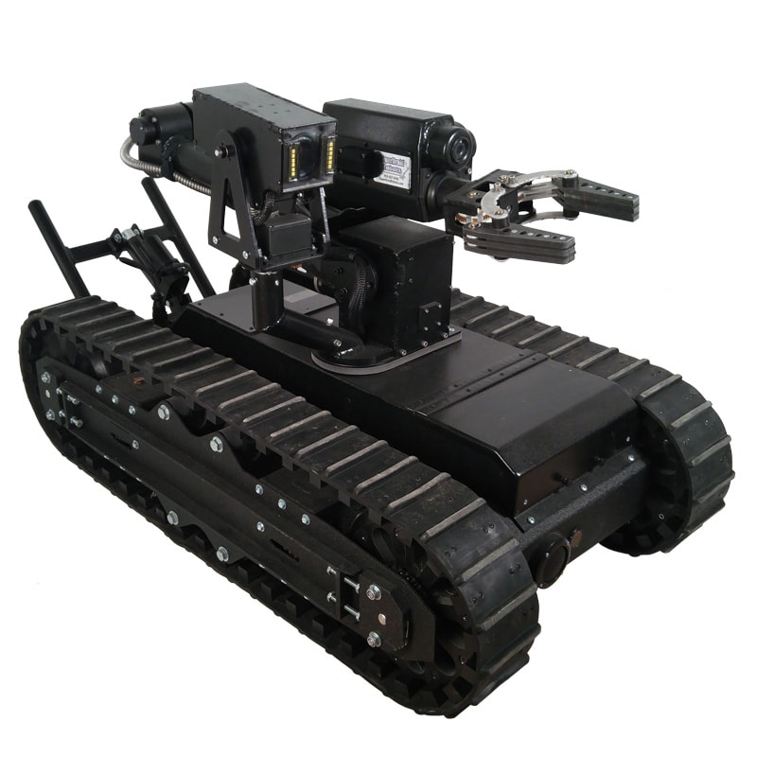

Roomba:

One feature of our product is autonomously picking up items and storing them inside the robot. This closely resembles the actions of a Roomba, which is an autonomous robot that picks up dirt in a specified area. Roombas’ have a navigation technology that allows it to map its surroundings and create a visual landmark to track where it has been. Our product will utilize a machine localization software to keep track of the location of the robot.

<https://store.irobot.com/default/home>

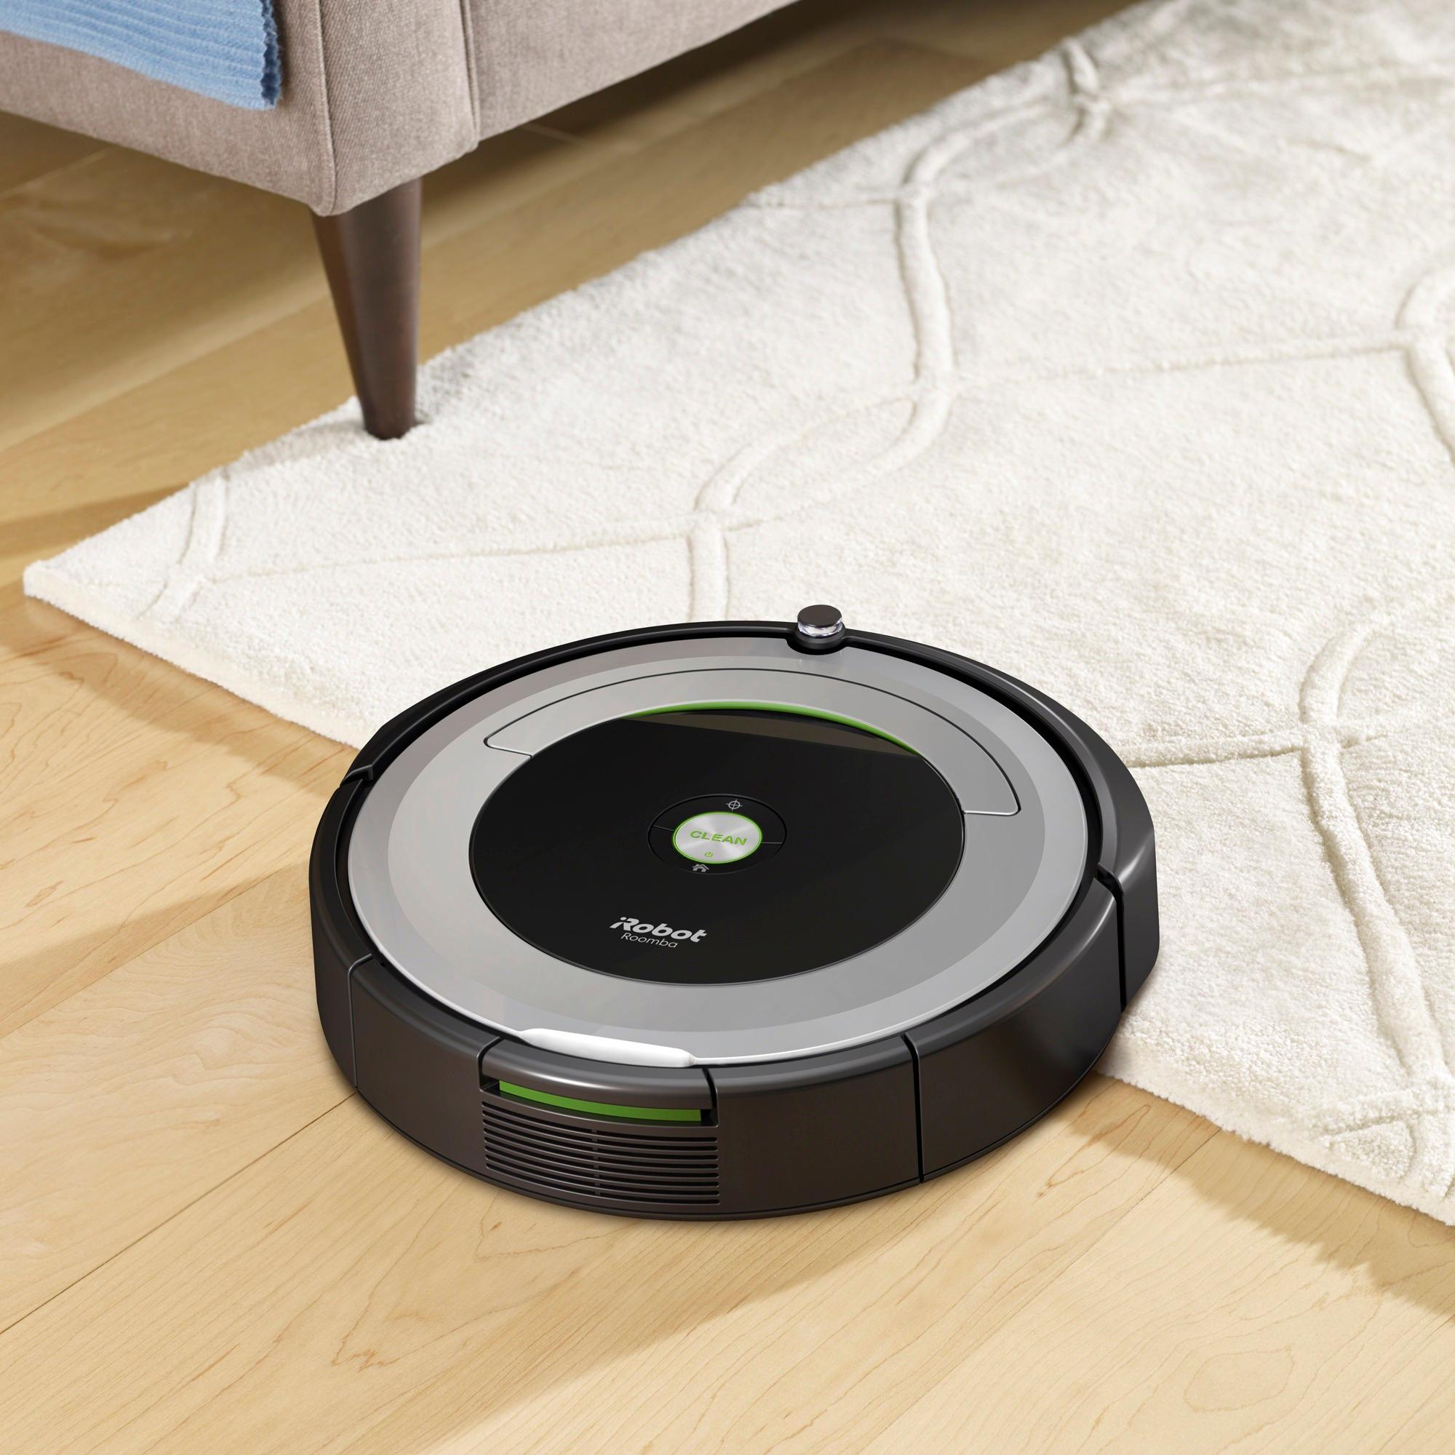

# **Societal and Environmental Impact**

* Help improve the speed and accuracy of routine operations
* Increase the efficiency of work and reduce human error
* Help reduce the risk of employee injury
* Enhanced customer value through focus of strategic work instead of mundane tasks
* Boosted corporate brand by signaling leading edge practices and implementation of innovative technology
* By delegating tasks to robots rather than people, in regards to safety and collateral damage, it will be a much affordable task to repair a robot rather than deal with medical bills and potential lawsuits due to human risk and injury at work
* Also playing into the factor of efficiency, robots because they do not experience physical exhaustion, can consistently and repeatedly perform a task at a constant rate

# **References**

Fruit Picking Robot

<https://www.intorobotics.com/fruit-harvesting-robots/>

Object Detection and Recognition

<https://ieeexplore.ieee.org/document/7053853>

Robot Grasping

<http://pr.cs.cornell.edu/grasping/IJRR_saxena_etal_roboticgraspingofnovelobjects.pdf>

Vector Machine Localization

<https://onlinelibrary.wiley.com/doi/epdf/10.4218/etrij.11.0110.0692>

Autonomous Mobile Robots

<https://ebookcentral.proquest.com/lib/csulb/reader.action?docID=3339191>

Raspberry Pi Machine Vision

<https://www.safaribooksonline.com/library/view/jumpstarting-raspberry-pi/9781680455458/c04.xhtml>

Machine Vision for Industrial Robotic Manipulator

<https://ieeexplore-ieee-org.csulb.idm.oclc.org/document/8627203>

Raspberry Pi Vision Research

<https://onlinelibrary.wiley.com/doi/abs/10.1111/j.1755-3768.2013.T028.x>

OpenCV Library Reference

<https://www.safaribooksonline.com/library/view/opencv-3-computer/9781788474443/cover.xhtml>

Computer Machine Vision

<https://www.safaribooksonline.com/library/view/computer-and-machine/9780123869913/xhtml/P1.html#ITR002tit>

Object Detection and Grabbing Based on Machine Vision

<https://ieeexplore-ieee-org.csulb.idm.oclc.org/document/8615062>